***NAME***: ***ALI SAYED ALI MOHAMED ESSA***

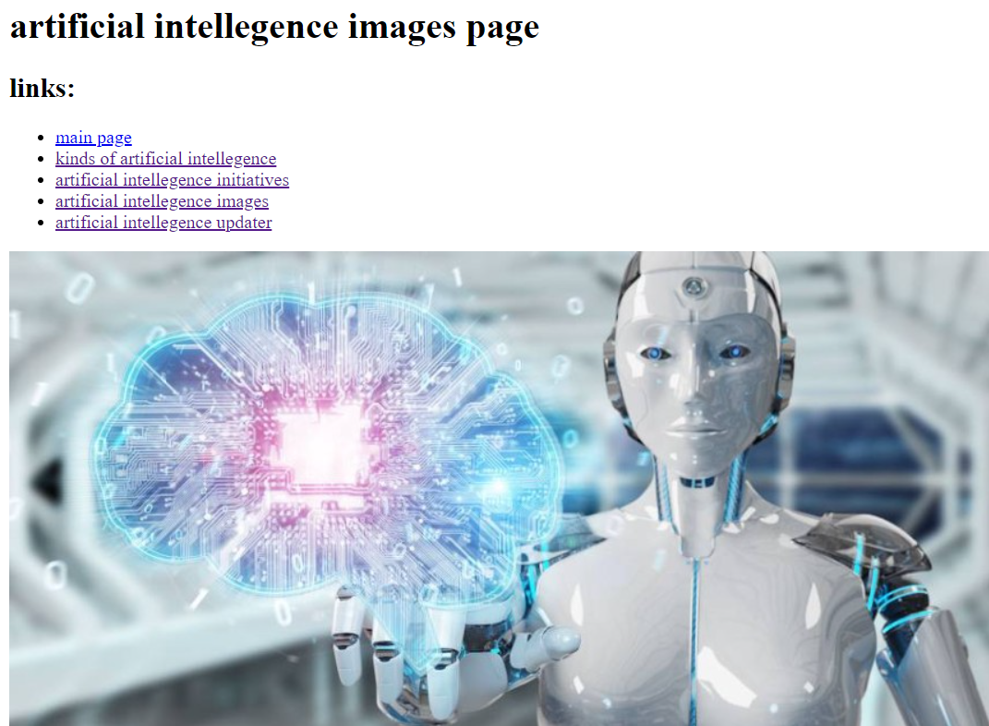

***STUDENT ID*** : **513**

***B.N* : *10***

***GIT HUB LINK :***

**TOPIC : *ARTIFICIAL INTELLEGENCE***

**TOPIC ADVANTAGES :**

**Artificial intelligence has become one of the terms that frequently ring in our ears during this period, due to its presence in many of the life sciences surrounding humans. With the development of technology and the entry of computers in all fields, artificial intelligence has become part of it, with expectations of imposing great dominance during the coming period.**

